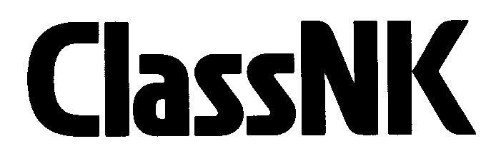 Application for Change of Ship Management
To: NIPPON KAIJI KYOKAI Classification Department
(Fax: +81-43-294-5449, E-mail: cldjt@classnk.or.jp)

From:
Name of Company |  | :
Contact Person / Title |  | :
Tel.: |  |  |  | Fax. : |  | e-mail:

Please be informed that ship management of the below mentioned vessel(s) have been changed to the new manager as followings:

Name of vessel(s) | Classification No. | Date of Manager Change
* If there is not enough space to write names of all vessels, please attach separate sheet.

Detail of New Ship Management Company
Name of Company |  | :
Contact Person |  | :
Contact Address: |  | :
Tel.: |  |  |  | Fax. : |  | e-mail:

