

MARITIME LABOUR CERTIFICATE
Issued under the provisions of Article V and Title 5 of the Maritime Labour Convention, 2006
(referred to below as “the Convention”)
(Note: This Certificate shall have a Declaration of Maritime Labour Compliance attached)
Under the authority of the Government of
THE REPUBLIC OF SOUTH AFRICA
By
NIPPON KAIJI KYOKAI
1714 STANDARD BANK CENTRE, MAIN TOWER
HEERENGRACHT
CAPE TOWN 8001

ALLOCATION NUMBER: …….. / …….. / ……..

Name of ship: ……………………………………………………………………………………………………….

Distinctive number or letters: ………………………………………………...……………………………………

Port of registry: ……………………………………………………………………………………………………..

Date of registry: ………………………………………………………………………………………………….....

Gross tonnage: ……………………………………………………………………………………………………..

IMO number: …………………………………………………………………………………………..……………

Type of ship: ………………………………………………………………………………………………….……..

Name and address of the shipowner: ……………………………………………………………………………

This is to certify:

- That this ship has been inspected and verified to be in compliance with the requirements of the Convention, and the provisions of the attached Declaration of Maritime Labour Compliance
- That the seafarer’s working and living conditions specified in Appendix A5-I of the Convention were found to correspond to the abovementioned country’s national requirements implementing the Convention. These national requirements are summarized in the Declaration of Maritime Labour Compliance, Part I.
This certificate is valid until ……………………………………………. subject to inspections in accordance with Standards A5.1.3 and A 5.1.4 of the Convention.

This certificate is valid only when the Declaration of Maritime Labour Compliance issued at

……………………………………………………. on ……………………………………………. is attached.

Completion date of the inspection on which this certificate is based was ……………………………………

Issued at ……………………..……………………….... on ………………………………………………..

……………………………………………………………………....
Signature of the duly authorized official issuing the certificate
(Seal or stamp of issuing authority, as appropriate)

Endorsements for mandatory intermediate inspection and, if required, any additional inspection

This is to certify that that ship was inspected in accordance with Standards A 5.1.3 and A 5.1.4 of the Convention and that the seafarers working and living conditions specified in Appendix A5-I of the Convention were found to correspond to the above mentioned country’s national requirements implementing the Convention.

Intermediate Inspection: Signed: …………………………………………………..
(to be completed between the (Signature of authorised official)
second and third anniversary dates)
Place: …………………………………………………….

Date: ……………………………………………………..
(Seal or stamp of the Authority, as appropriate)

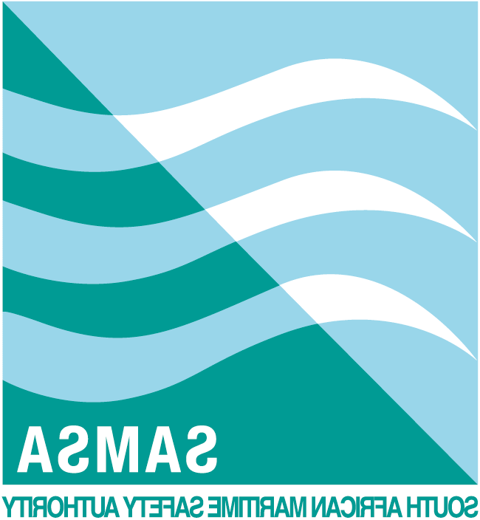
Additional endorsements (if required)
This is to certify that the ship was the subject of an additional inspection for the purpose of verifying that the ship continued to be in compliance with the national requirements implementing the Convention, as required by Standard A3.1, paragraph 3, of the Convention (re-registration or substantial alteration of accommodation) or for other reasons.

Additional Inspection: Signed: ……………………………………………………
(if required) (Signature of authorised official)

Place: ……………………………………………………..

Date: ………………………………………………………
(Seal or stamp of the authority, as appropriate)
Additional Inspection: Signed: ……………………………………………………
(if required) (Signature of authorised official)

Place: ……………………………………………………...

Date: ………………………………………………………
(Seal or stamp of the authority, as appropriate)

Additional Inspection: Signed: ……………………………………………………
(if required) (Signature of authorised official)

Place: …………………………………………………......

Date: ……………………………………………………...
(Seal or stamp of the authority, as appropriate)

